

Test Execution Activity Part 3 – Evidence Collection
OrangeHRM Testing

Document ID | DOC - 0005
Version | [1.0]
Date | 29-June-2026
Prepared by | Team B(Nyeleti Maswanganye |Luthando Ndzendevu | Kamogelo Sekhaolelo)
Approved by | Issac Mhlangu
Classification | Confidential

1. Project Overview

Module 1: Login
Test Case ID: TC_LOGIN_001 (Login)
- Tester Name: Nyeleti | Date: June 29, 2026 | Result: Pass
- Saved Screenshot Filename: SS_TC_LOGIN_001_PASS.png
- Notes: The system works correctly. It checks the username and password, logs the user into the site, and loads the main dashboard safely. Screenshot captures the successful redirect landing page.
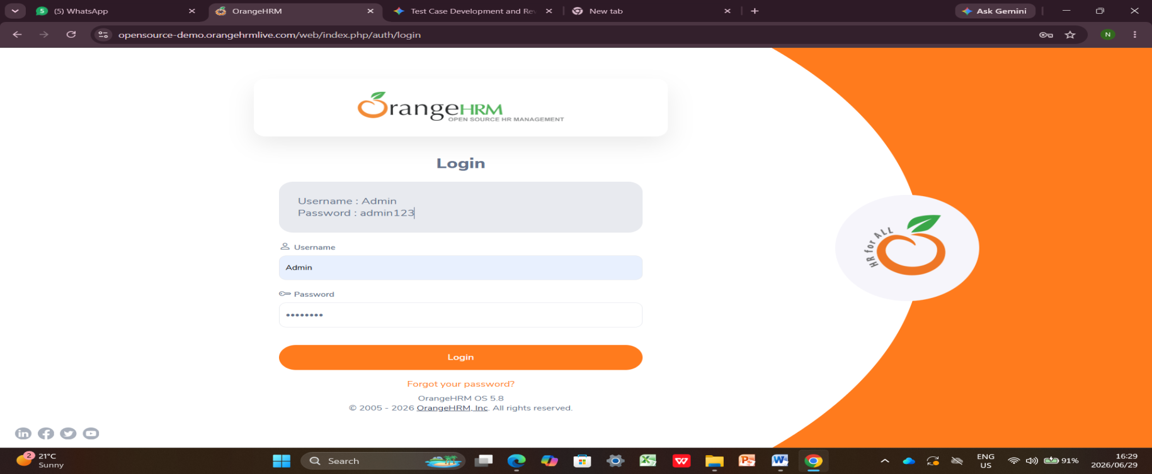
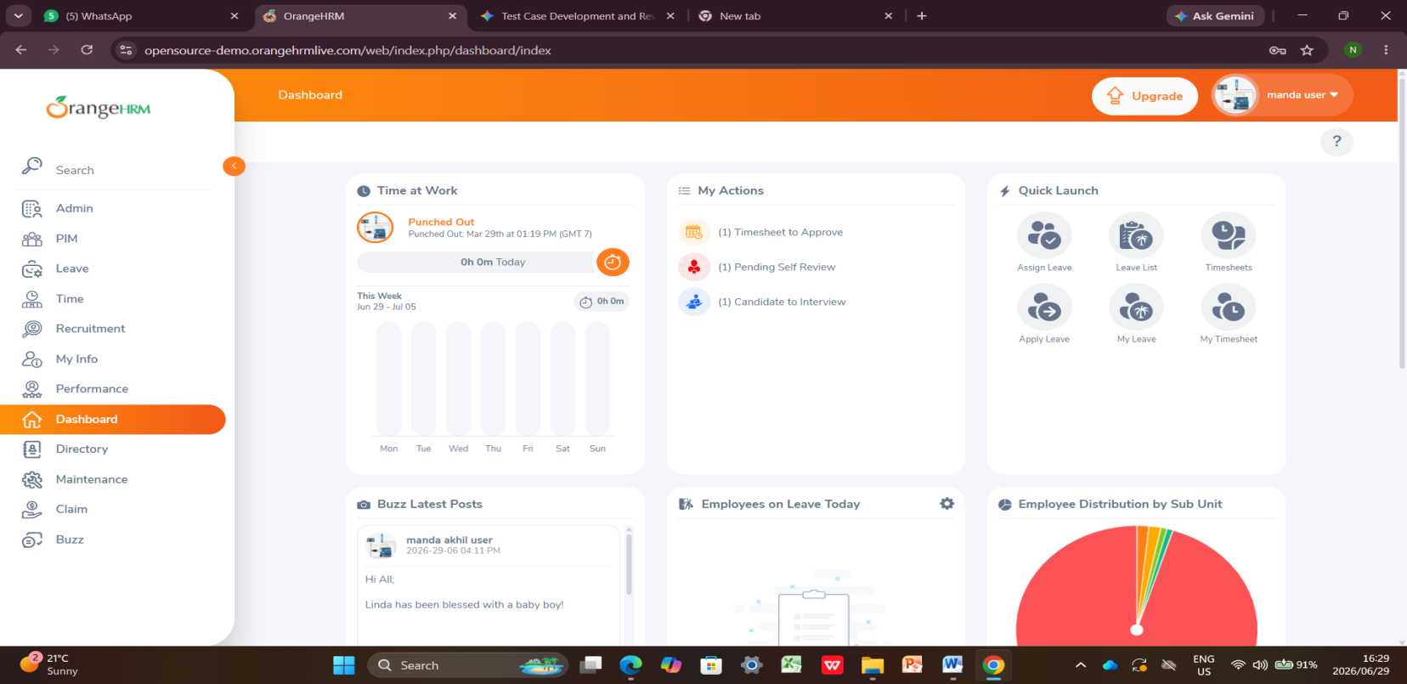

Test Case ID: TC_LOGIN_002 (Login)
- Tester Name: Nyeleti | Date: June 29, 2026 | Result: Fail
- Saved Screenshot Filename: SS_TC_LOGIN_002_FAIL.png
- Notes: Security failure. The website incorrectly allows access to the system even when using an old, expired password instead of blocking the user.
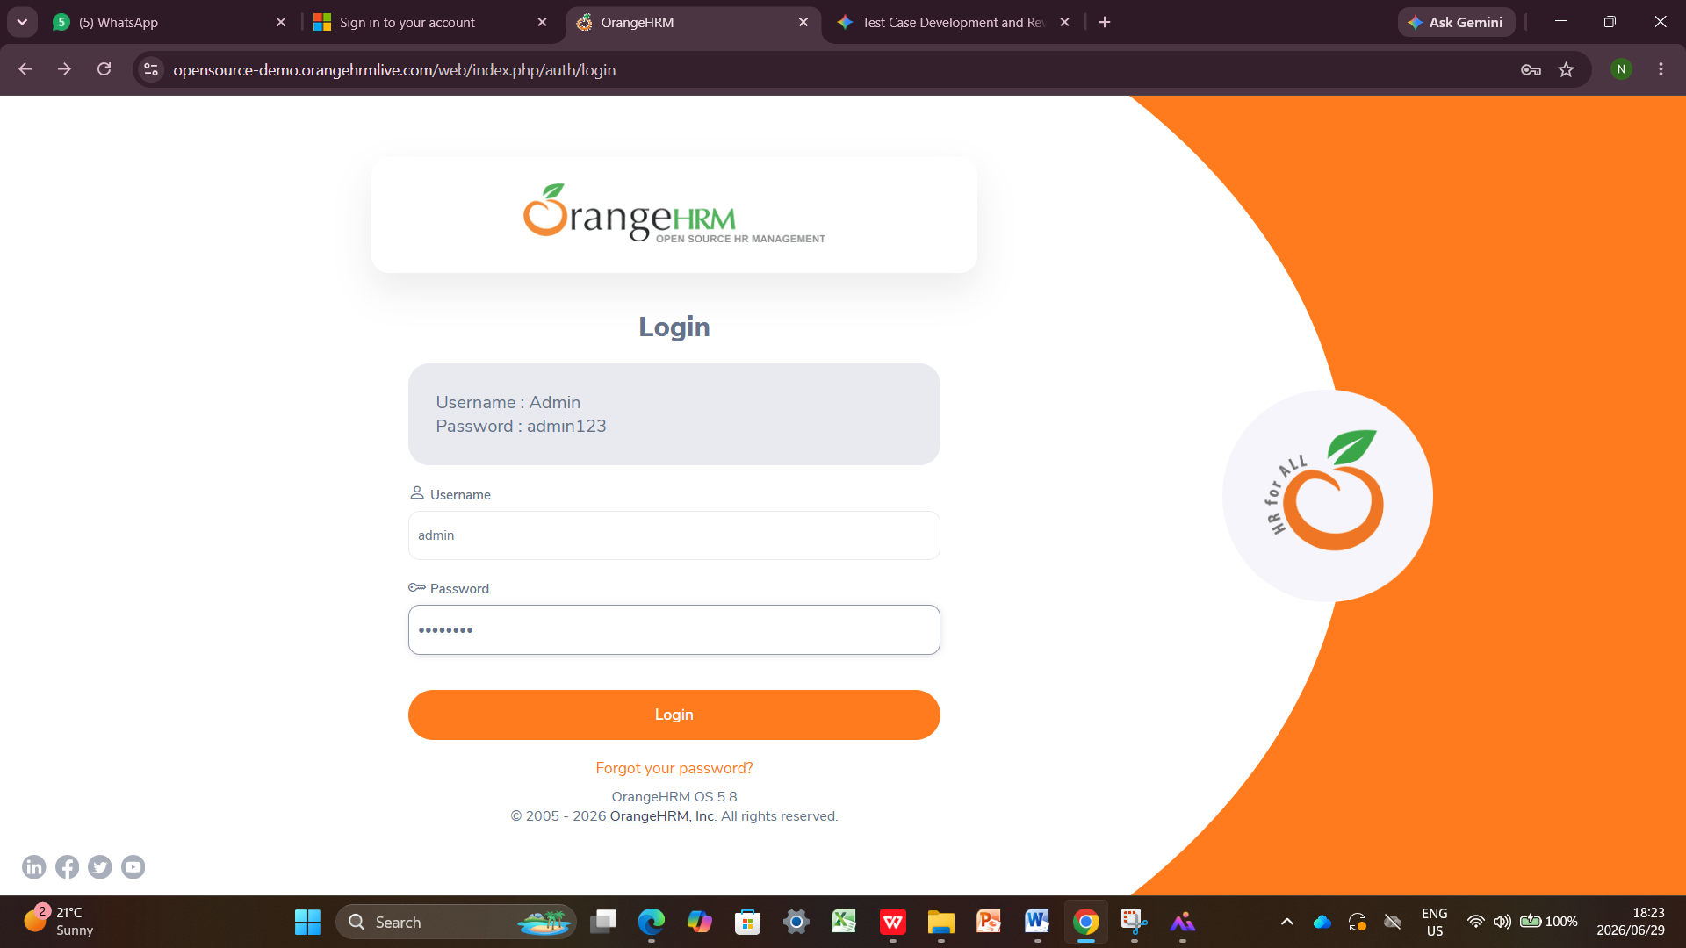
Module 2: Dashboard
Test Case ID: TC_DASH_001 (Dashboard)
- Tester Name: Nyeleti | Date: June 29, 2026 | Result: Pass
- Saved Screenshot Filename: SS_TC_DASH_001_PASS.png
- Notes: Navigation links are working perfectly. Clicking the quick shortcut button opens up the correct feature page immediately.
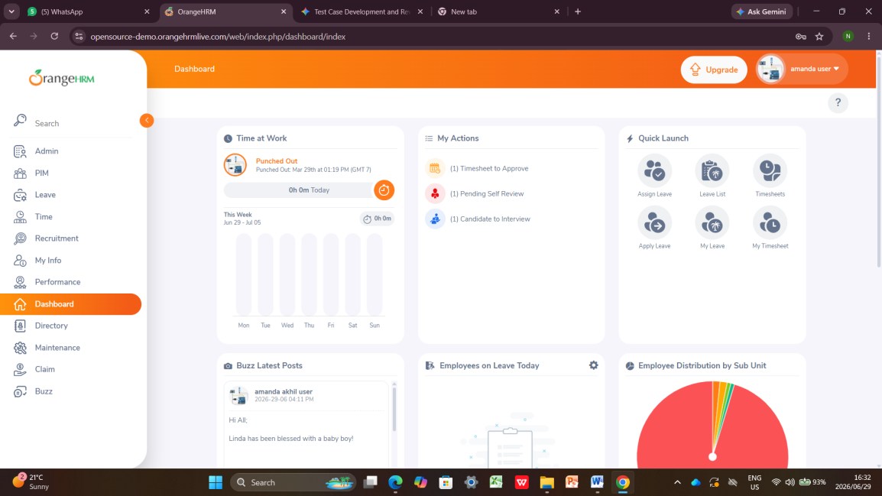
Test Case ID: TC_DASH_002(Dashboard)
- Tester Name: Nyeleti | Date: June 29, 2026 | Result: Pass
- Saved Screenshot Filename: SS_TC_DASH_002_PASS.png
- Notes: Quick Launch navigation panel components dynamically adjust and render cleanly. Verified on Chrome.

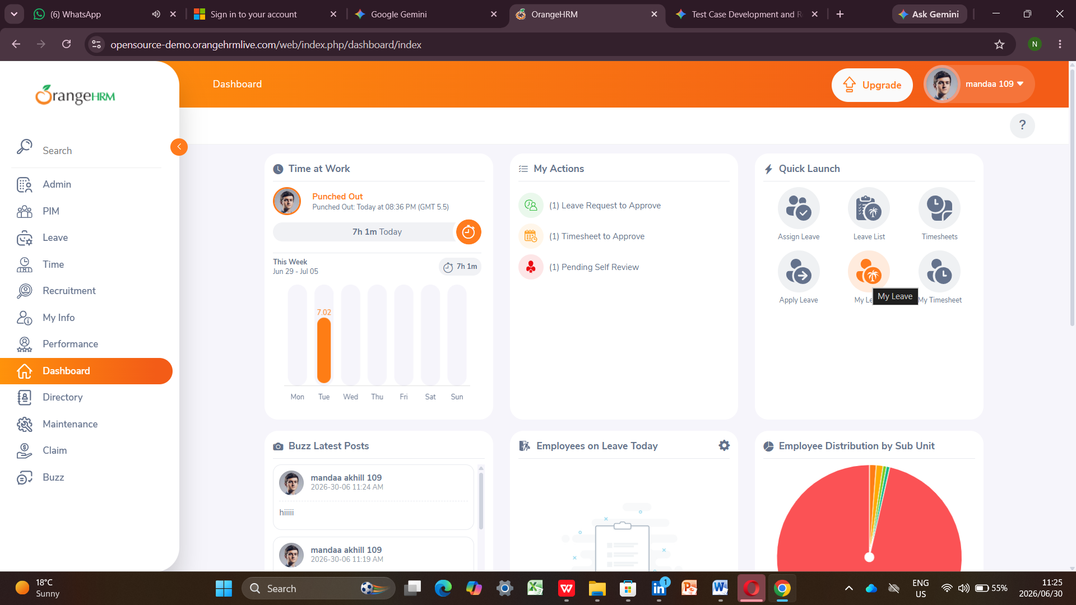

Module 3: Admin
Test Case ID: TC_ADMIN_001 (Admin)
- Tester Name: Luthando | Date: June 29, 2026 | Result: Pass
- Saved Screenshot Filename: SS_TC_ADMIN_001_PASS.png
- Notes: The data list loads fully from the database, and clicking the column headers sorts all items alphabetically without any errors.
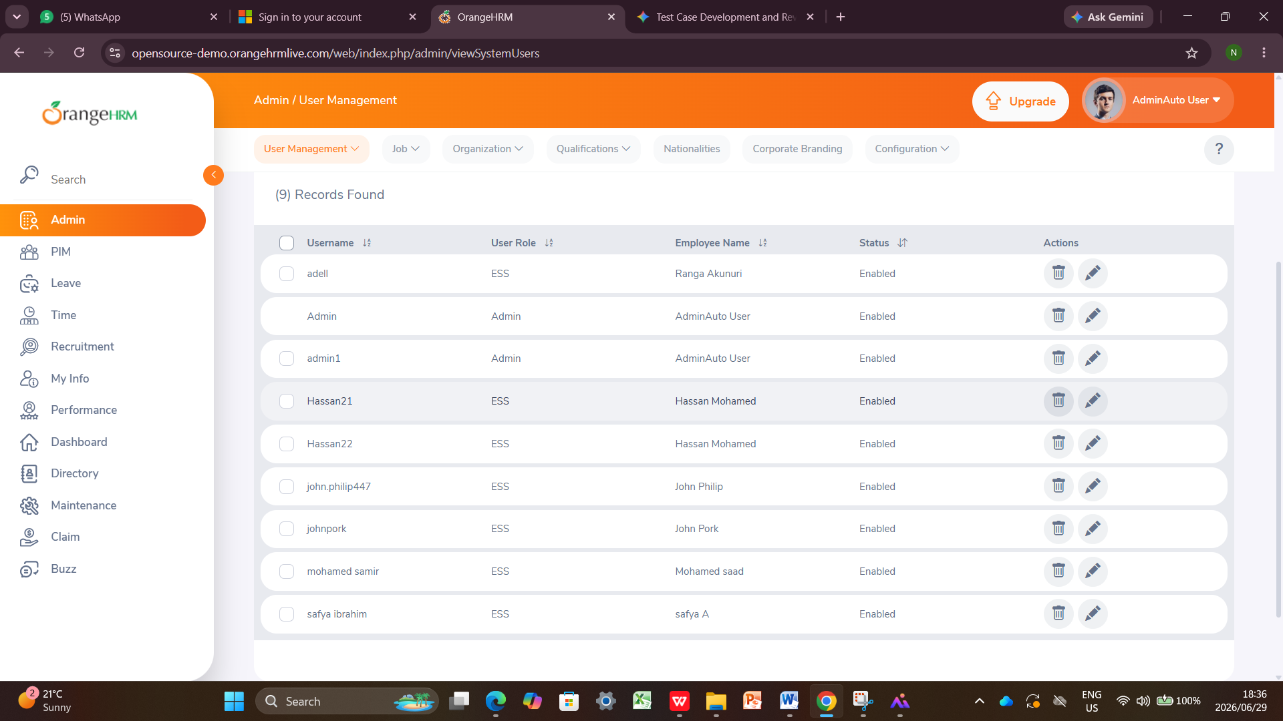
- Test Case ID: TC_ADMIN_002
  - Module: Admin
  - Tester Name: Luthando
  - Date Executed: June 29, 2026
  - Result:Pass
  - Saved Screenshot Filename: SS_TC_ADMIN_002_FAIL.png
  - Browser Used: Mozilla Firefox
  - Relevant Notes / Defect Evidence: Input validation safety checks work perfectly. The system correctly blocks form submission and displays a validation warning when required fields are left blank.
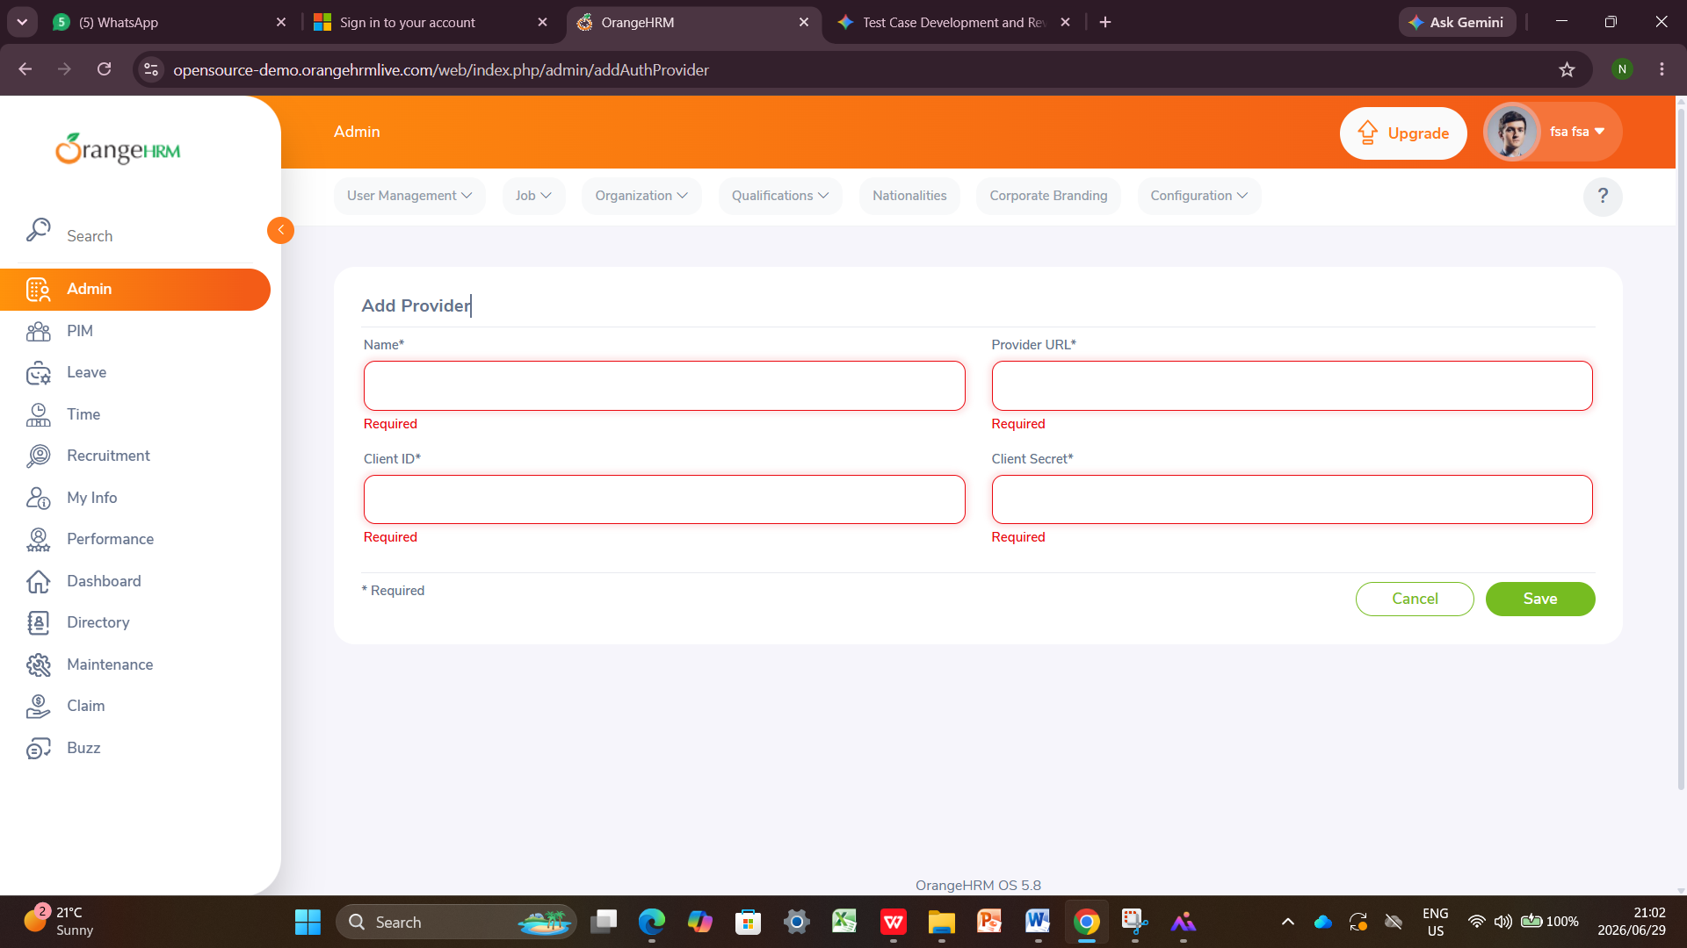

Module 4: PIM
Test Case ID: TC_PIM_001 (PIM)
- Tester Name: Luthando | Date: June 29, 2026 | Result: Pass
- Saved Screenshot Filename: SS_TC_PIM_001_PASS.png
- Notes: Saving new profiles works flawlessly. The system stores the new worker details in the database and shows a green success message on the screen.
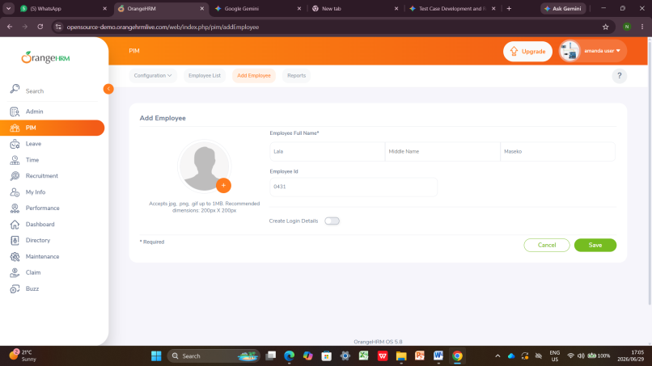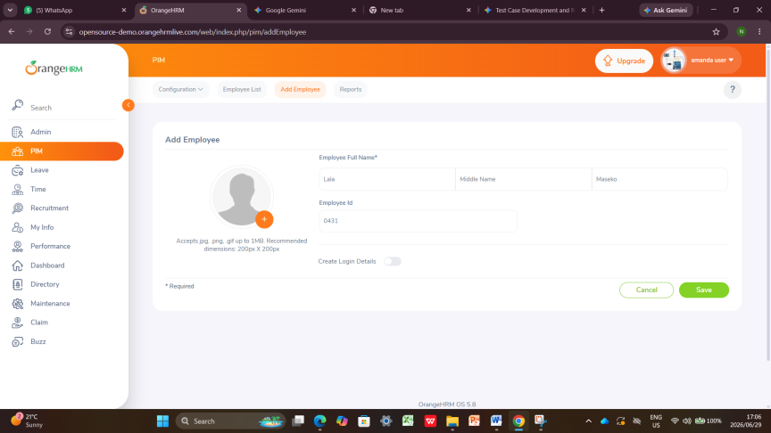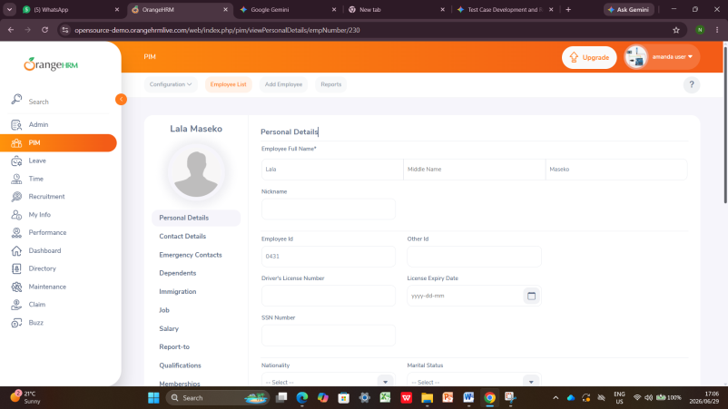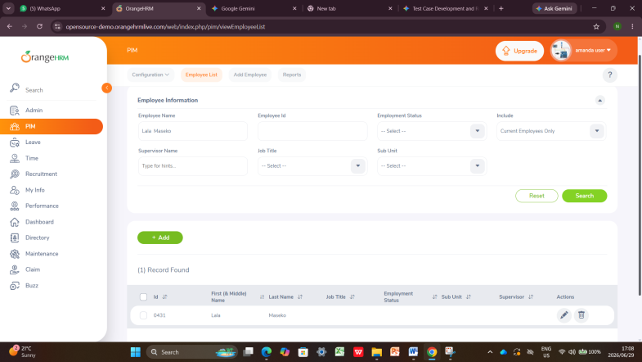
Test Case ID: TC_PIM_002 (PIM)
- Tester Name: Luthando | Date: June 29, 2026 | Result: Pass
- Saved Screenshot Filename: SS_TC_PIM_002_PASS.png
- Notes: The search tool filters data accurately. Typing an exact ID number into the search box finds and displays that specific employee record instantly.
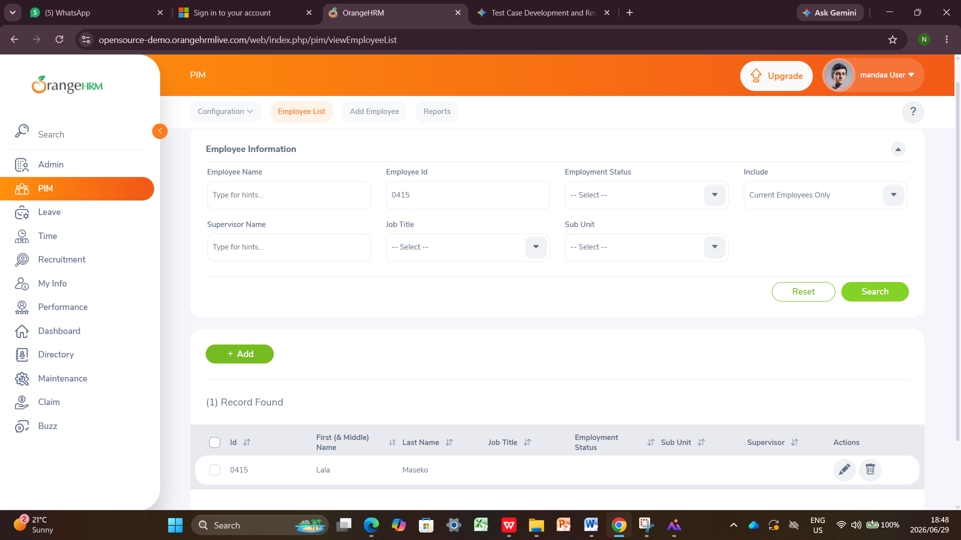

Module 5: Leave
Test Case ID: TC_LEAVE_001 (Leave)
- Tester Name: Kamo | Date: June 29, 2026 | Result: Pass
- Saved Screenshot Filename: SS_TC_LEAVE_001_PASS.png
- Notes: The user interface displays correctly. The screen loads with all necessary search filters, menus, and selection boxes in the right places.

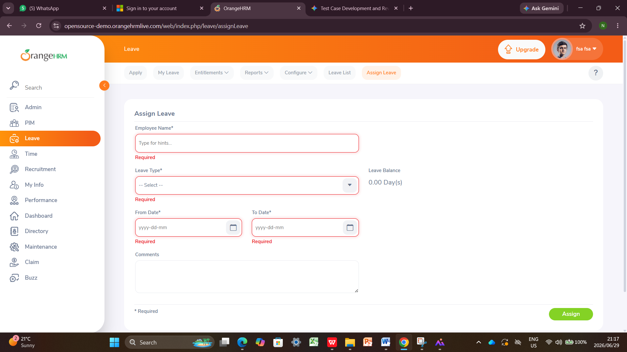
Test Case ID: TC_LEAVE_002 (Leave)
- Tester Name: Kamo | Date: June 29, 2026 | Result: Blocked
- Saved Screenshot Filename: SS_TC_LEAVE_002_BLOCK.png
- Notes: Testing was stopped by a website freeze. The page loaded endlessly until the system timed out, making it impossible to finish the test steps
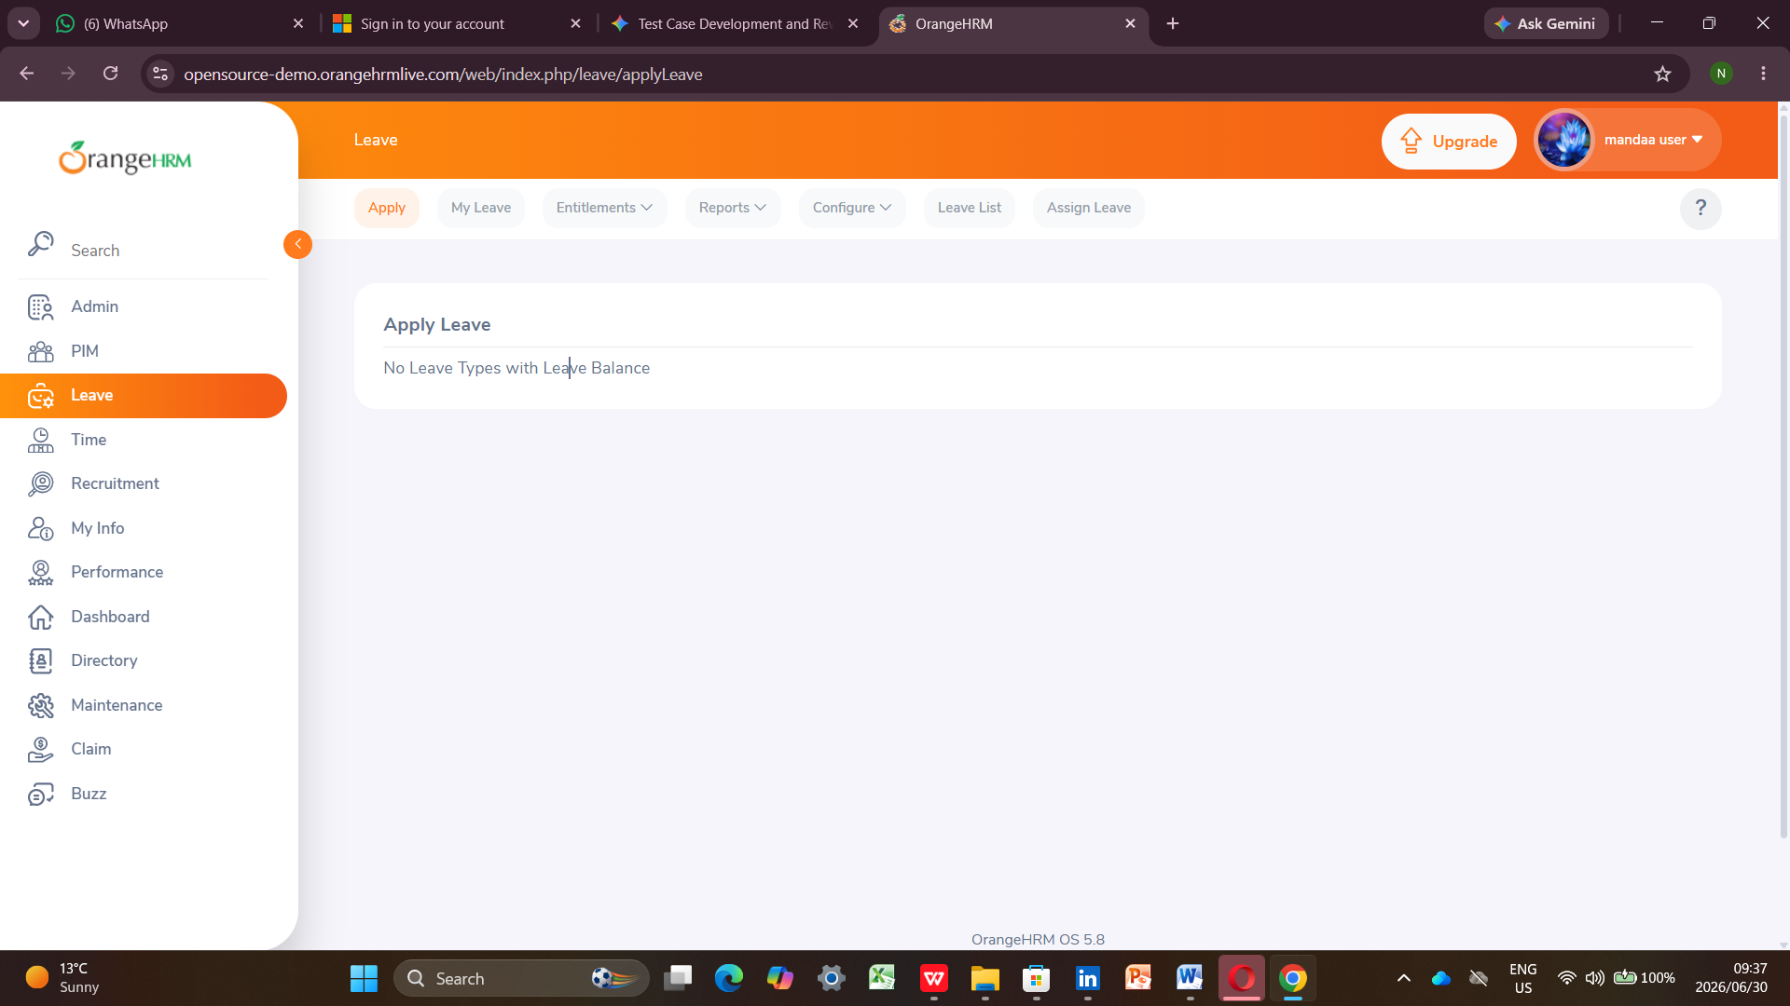

Module 6: Time
Test Case ID: TC_TIME_001 (Time)
- Tester Name: Kamo | Date: June 29, 2026 | Result: Pass
- Saved Screenshot Filename: SS_TC_TIME_001_PASS.png
- Notes: Math calculations are accurate. The system accepts decimal numbers for hours worked and adds them to the total timesheet score correctly.
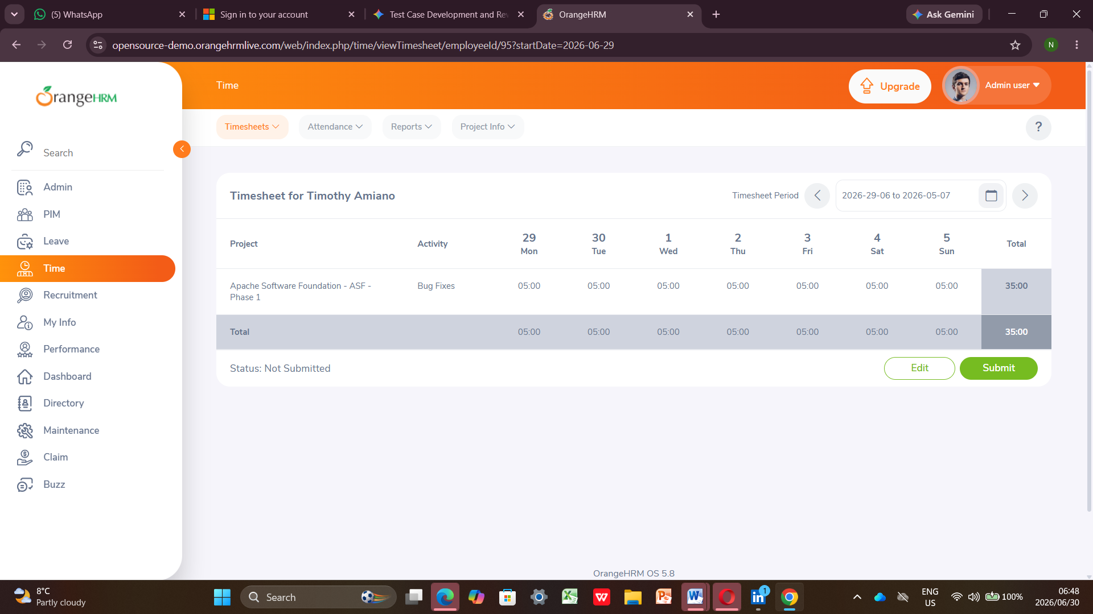

Module 7: Recruitment
Test Case ID: TC_REC_001 (Recruitment)
- Tester Name: Nyeleti | Date: June 29, 2026 | Result: Fail
- Saved Screenshot Filename: SS_TC_REC_001_FAIL.png (Referenced from source file image_d94c40.jpg)
- Notes: System Instability Defect. Workflow breaks during candidate state updates. The screenshot highlights a red functional toast error message stating "Error: Unexpected Error Occurred," accompanied by an infinite loading animation icon that prevents the system from completing the shortlisting process.
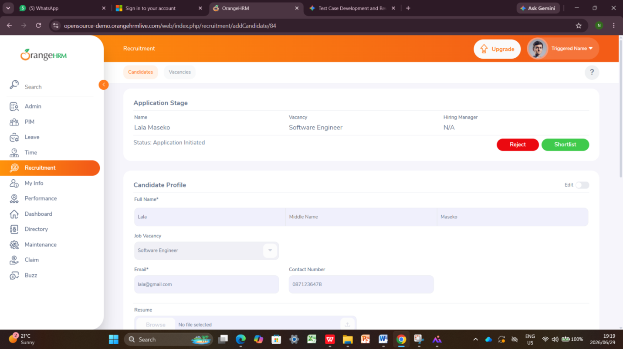
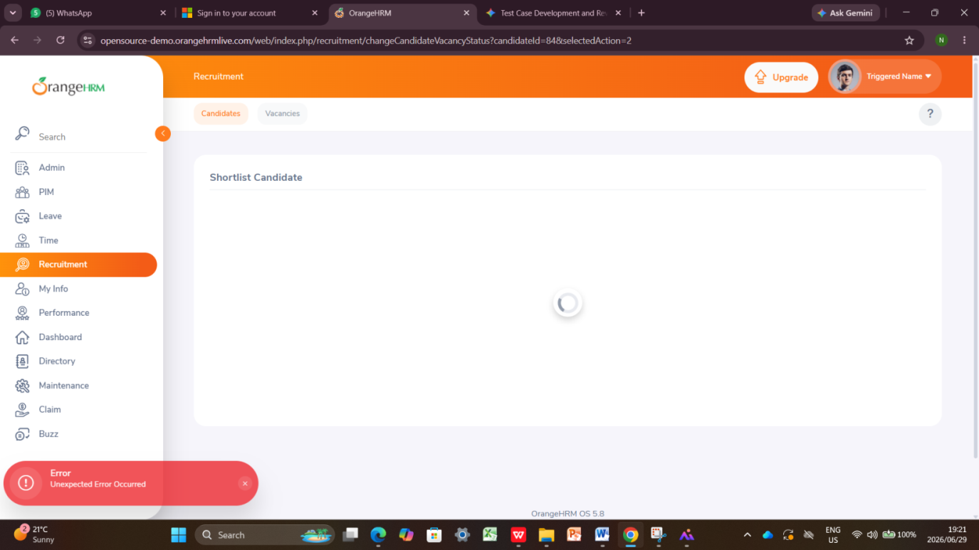
Test Case ID: TC_REC_002 (Recruitment)
- Tester Name: Nyeleti | Date: June 29, 2026 | Result: Pass
- Saved Screenshot Filename: SS_TC_REC_001_PASS.png
- Notes:Resume upload widget attaching documents successfully.
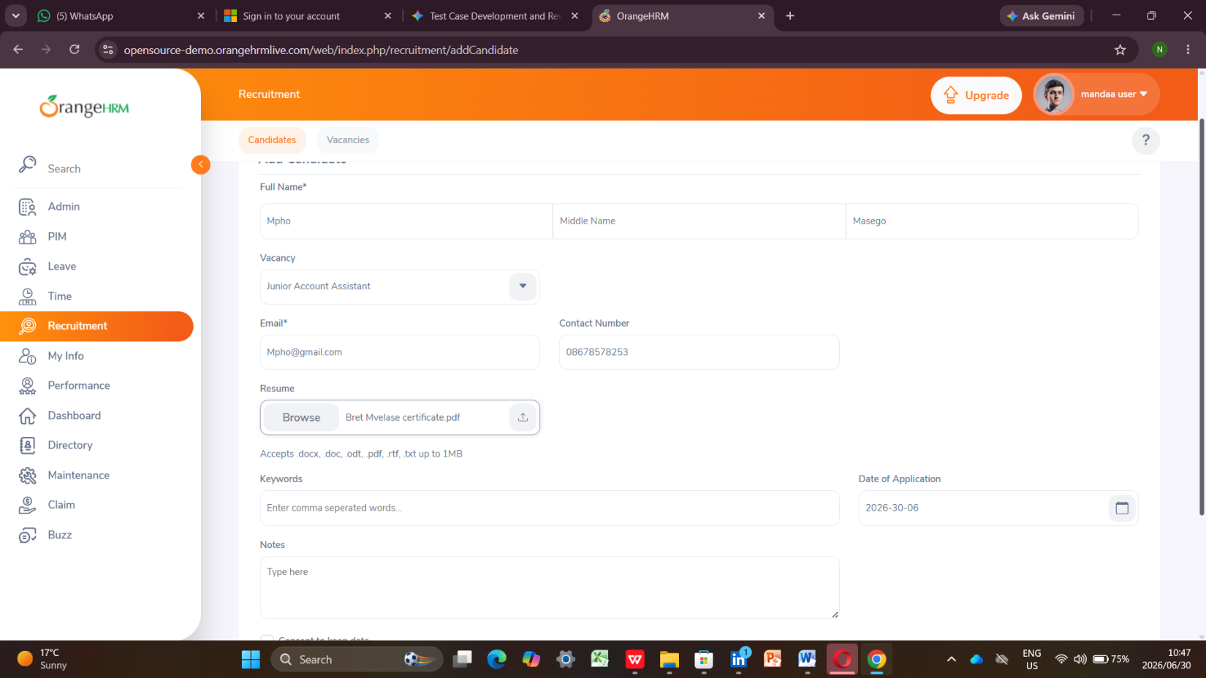

Module 8: Performance
Test Case ID: TC_PERF_001 (Performance)
- Tester Name: Luthando | Date: June 29, 2026 | Result: Pass
- Saved Screenshot Filename: SS_TC_PERF_001_PASS.png
- Notes: The performance metrics grid displays clearly. All text rows and columns load with clean layouts and zero broken code strings.
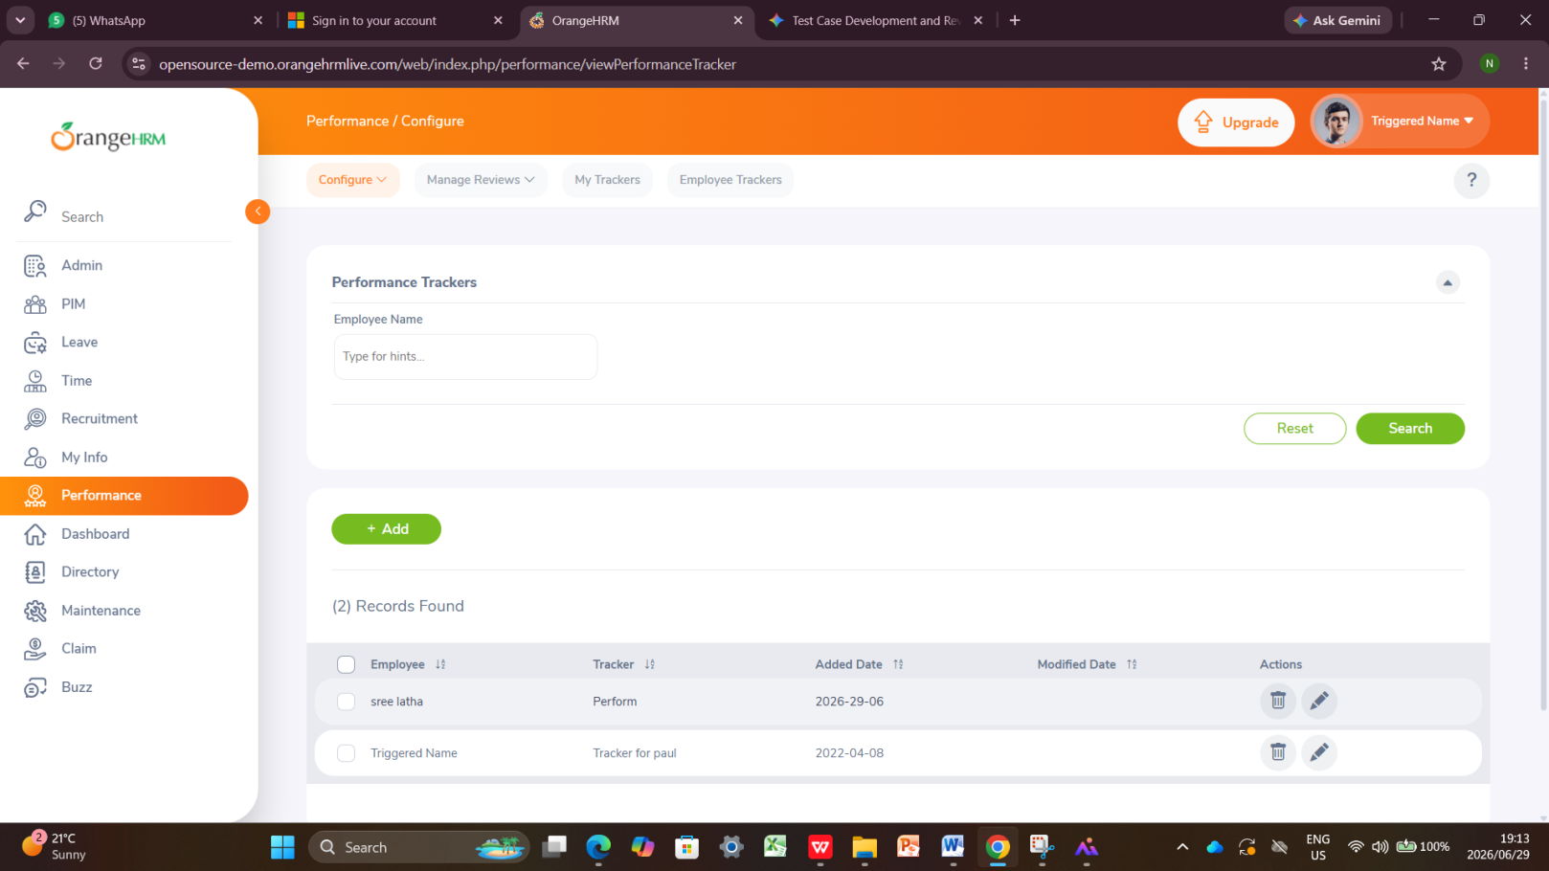
Test Case ID: TC_PERF_002 (Performance)
- Tester Name: Luthando | Date: June 29, 2026 | Result: FAIL
- Saved Screenshot Filename: SS_TC_PERF_002_FAILpng
- Notes: Component crash. Accessing the KPI metrics layout crashes and displays raw unhandled code strings. Verified on Firefox.

Module 9: My Info
Test Case ID: TC_MYINFO_001 (My Info)
- Tester Name: Kamo | Date: June 29, 2026 | Result: 1 Pass & 1 Not Exceution
- Saved Screenshot Filename: SS_TC_MYINFO_001_PASS.png
- Notes: Profile editing works perfectly. The system saves any changed personal details securely, and the new data stays visible when refreshing the page.

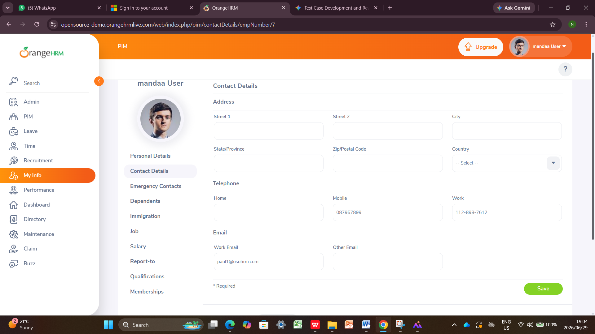

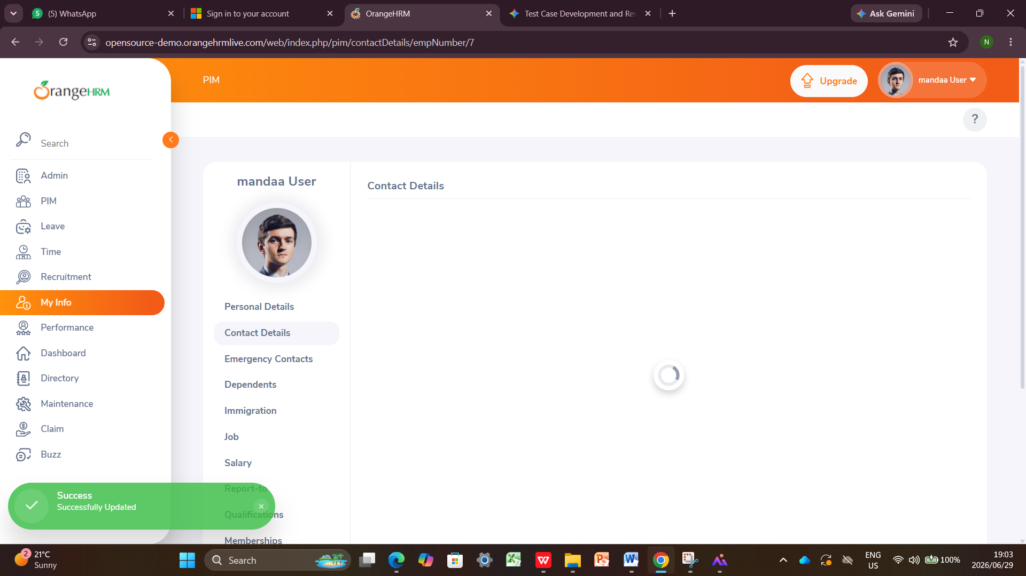

NOTE Use this callout style to draw attention to important information, warnings, or reminders within the document body.

